
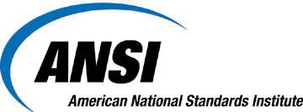
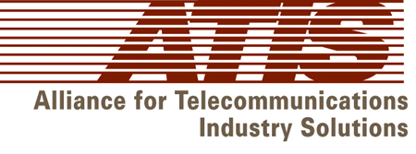



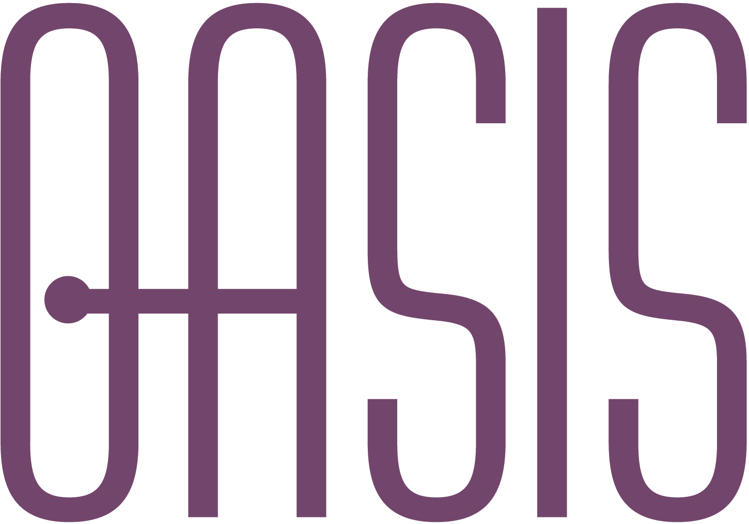

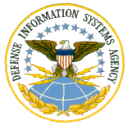

Challenges for IT Standardization


July 9-10, 2002
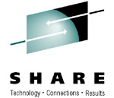

Green Auditorium, Administration Building

National Institute of Standards & Technology

Gaithersburg MD 20899

Information Technology (IT) encompasses the art and applied sciences that deal with functions such as the communication, capture, representation, processing, security, transfer, interchange, presentation, management, organization, storage, and retrieval of data and information. The innovative IT industry sector continues to drive the United States economy and our ability to compete globally. Advances in computers and communications technology have provided the building blocks on which new industries have evolved. Virtually every business in the United States in every sector depends on IT to aid in the development, production, marketing, and support of its products and services. IT has now become an intrinsic part of business, resulting in many electronic business modes of operation - now commonly referred to as e-Business.

Standards are vital to the deployment of e-Business. This has led to a flurry of standards development and deployment activity by numerous formal Standards Developing Organizations (SDOs), consortia, trade associations, and individual companies. There is a real need for coordination of these efforts to avoid duplicative - or worse, conflicting - standards. This Standards Coordination Conference will explore in depth the standardization efforts underway in key industries such as healthcare, telecommunications, and retailing. Similarly, the Conference will explore standardization efforts that seek to span multiple industry sectors and cross national boundaries.

A recent RAND report* noted that the convergence of new information technologies, including cellular, broadcasting, Internet, and intelligent transportation systems (ITS), present new challenges to industry and international standards organizations. The Conference will seek to begin a dialog and identify issues and next steps for the key questions now being raised by legislators and others, such as:

- Does the IT industry face special challenges that impair its ability to compete domestically or internationally?
- Should the IT industry shift more towards using consortia-developed standard?
- Does the recognition of consortia-developed standards present difficulties for businesses outside IT-related fields?
- How is the IT standards community dealing with the need for speed in standards development?
- How are Federal agencies using IT standards?
- What will it take to get the formal Standards Development Organizations (SDOs) and consortia to work together?

The Conference will kick off with a presentation from a key member of Congress to focus our attention on the key issues facing those who would attempt to set standards today.

This Standards Coordination Conference is sponsored by the American National Standards Institute’s (ANSI) Information Systems Standards Board (ISSB), and co-sponsored by the National Institute of Standards & Technology (NIST), the InterNational Committee for Information Technology Standards (INCITS), Health Level 7 (HL 7), the Alliance for Telecommunications Industry Solutions (ATIS), the Department of Defense Defense Information Systems Agency (DISA) Center for Standards, the Uniform Code Council (UCC), the Institute of Electrical and Electronics Engineers, Inc. (IEEE), RosettaNet, SHARE Inc., OASIS and Open Applications Group. Other co-sponsors are welcome. The primary obligations of co-sponsors are to notify their membership of the opportunity to participate in this Conference and to subsequently report back to their membership on the results of the Conference.

Speakers will be asked to address the broader issues described above in the context of the not only the work they are specifically doing, but also to provide information on what other projects are underway in that field. At the end of the conference, there will be final session to capture the issues raised and the answers offered, and, most importantly, to discuss possible next steps.

This conference is appropriate for a wide variety of individuals - policy developers and decision makers, industry and government executives, IT users and developers, CEOs, CTOs, & CIOs, product managers, system integrators, participants in standards development activities, and anyone who wants to keep abreast of developments in this fast moving arena.

There is no registration fee for attendees. For security reasons, in order to gain admission to the building, all attendees must register in advance. All registrations must be received by Friday, June 28, 2002. For additional information and to register for the conference, go to: http://www.ansi.org/rooms/ROOM_37/

NIST Visitor Information is available at: http://www.nist.gov/public_affairs/visitor/visitor.htm

* Scaffolding the New Web: Standards and Standards Policy for the Digital Economy

http://www.rand.org/publications/MR/MR1215/

